Contents

Gather Information 1

Customer details 1

Internal Business Users/Team 2

Team Tasks 2

Overall Output 3

Workshop 3

References 5

1. Your DevOps implementation strategy, process or framework.

High Level Process consist of identifying the current Tasks Request the Names of each person in the company

2. Design a process or framework for modernizing existing code. 15 marks

## Gather Information

The process that I have gone with consists of the following:

Identify what is currently in place by

* For each person who is available send out a Survey or email to solicit info
* Send email to gather what each person's current tasks are

Name : Ren

|  |  |  |  |  |  |
| --- | --- | --- | --- | --- | --- |
| Task | Details - Steps | Time Spent and How Often | Dependencies (where do you get info/files from who or what dept) | Revenue Generation | End Result Where do you send it? |
|  |  |  |  |  |  |
|  |  |  |  |  |  |

Do you have any Pain Points/Constraints?

What would you do to improve?

If customer is involved how happy are they and who are they?

Why are you doing the task?

Output

A list of Tasks that the current employees are doing

### Customer details

Gather Customer information – Contact each Customer by sending a Survey or questionnaire on how the service that is provided

* How is it performing
* How it can be improved
* Any additional services that could be provided (need to generate income plus keep our existing customers happy)

### Internal Business Users/Team

Gather Business information – Ask the Business Stakeholders

* What should we stop doing?
* What should we start doing?
* What should we continue to deliver?
* What are the pain points?
* What can be improved?
* What additional services could be provided?
* Future needs

### Team Tasks

#### Input

Meet with Ren and have a conversation on the lay of the land, company history on how they got to where they are, identify:

* who the key stakeholders are in the company,
* who are the GO TO people?(they may not be in charge but are the spine of the company)
* What makes Ren tick (crucial for motivating and ensuring Ren is part of the modernisation)
* where are their strengths?
* what would they like to achieve?

#### Tasks

Ren mentions a Report that is requested from the customer on an adhoc basis and it turns out that it takes half a day to produce and is not charged for, Ren thinks that it is something that should be automated as the steps are documented, it would bring in revenue and is not complicated but time consuming manually, Ren discusses with Jalen and Jalen agrees that they estimate it would take 2 days to automate, the customer is contacted and confirm it is something that is likely to increase and expand in the future and they are willing to pay for it with the view of adding functionality in the future, the Customer Rep believes they could pitch it to other customers as it would be useful to them

#### Output

Ren feels involved and motivated, Ren is happy that it is one less task for Ren to do, Jalen is happy to automate something that is going to bring in revenue plus potentially additional revenue to save the company

#### Input

Meet with Jalen and identify:

* What are their aspirations (gauge how happy they are)
* Is you Role defined and clear?
* Are they content in their role?
* What do you not like about your role
* What training or support do you need
* Do you feel empowered and trusted

#### Tasks

Highlight the DevOps process that is planned to implement in the Short/Medium and Long Term, ask them their thoughts to ensure their Buy In. Explain ‘What’s in it for them” that it will improve their day to day role by automating and reducing mundane Tasks to allow them to concentrate on the more interesting Tasks, Potentially less need for weekend support as automation Tests run as part of new process

#### Output

Buy In from Jalen/Motivated/Gaining Technology Knowledge/Less Manual Tasks/Improved Quality less Stress/

### Overall Output

Based on the Task Feedback List the Tasks with each person’s name associated

### Workshop

Organise a Workshop and invite All the Team

For each Task Discuss

* The Priority - Prioritise the Tasks based on Revenue/Value to the Team or the Customer,
* Reprioritise as needed(Start with No. 1 and use the concept of is No. 2 more of a priority than no.1 and so on – is it smaller/equal or larger than the previously discussed Tasks) High Level Agile principles could be used/implemented here
* Is the Task across several people, can it be reduced to less people?(reduce dependencies increase ownership and empowerment and possibly time?)
* Are Tasks suitable for Automation- Return of Investment(Reduced Time/Cost of Investment)

#### Output

Prioritised List(Backlog/List of current Tasks that take up resources)

Tasks to Automate(Team spends less time working on the Task)

All Stakeholder

Invite ALL the Stakeholder and present the current state of what takes time across the team

Showcase the Task List the IT team have identified

Plot Future

#### Short Term

Identify each Task

Prioritise

# Design a simplified process or framework for implementing DevOps throughout the company. 15 marks

DevOps is summed up nice [here](https://www.synopsys.com/glossary/what-is-devops.html#:~:text=Definition,than%20traditional%20software%20development%20processes.) as a combination of practices and tools designed to increase the ability to deliver software and services faster than the traditional SDLC. DevOps processes plus some Agile practices are being proposed for Shinty Software. The implementation will be broken into 3 Phases(Short Term/Medium and Long Term) Short Term we will use the resources at our disposal.

We need to identify what Tasks are currently taking the employees time

* Prioritise each Task
* Identify what improvements can be made
* Showcase the value of the improvements less resources needed –
* Increased Income –
* Increased Team Morale – Job Satisfaction
* Improved Quality – Happier Customers and End Users
* Reduced Time to Market
* Earlier Feedback to ensure what is being Built is correct
* The advantages of Automation
* Reducing Waste
* Added Value
* Concentrate on producing Minimum Viable Product
* Demo the completed Tasks to the Business
* Quick Wins/Low Hanging Fruit
* Researching and introducing Best Practice from the start

#### Medium Term

Increased Automation

Continuous Integration

Continuous Delivery

Maintaining Best Practice

#### Long Term

Each part of the Pipeline is automated as much as possible by decreasing each Manual Task

Using the available tools to link and connect each part of the pipeline

Continuous Deplyment – the Team are Performing and each part of the pipeline is in place and new features are incorporated with ease due to Test Case automation being run as part of each Delivery and Deployment

Maintaining Best Practice

Researching further Technology/Tools

Plot future – the importance of early feedback/the advantages of automation/the value of each person/eliminating/reducing waste/adding value internally/job satisfaction/Minimum Viable Product and Demo to all focusing on value short term quick wins low hanging fruit/medium term reduce manual intervention increase speed to market/long term CI CD automated Production Releases

List the most time-consuming tasks/most repetitive tasks with a view to automating - are all the steps/people needed or are there any new technologies that can help make more efficient and thus more cost effective

Any Single Points of Failure

Arrange a Workshop with ALL the stakeholders of the company

In the Workshop present the current tasks as the IS NOW with the people's names that are attached

Ask each person in their opinion(this encourages ownership/responsibility/empowerement) to prioritse the top 10 Tasks(from 1 to 10) There may be 50 to 60 tasks but due to time and resource constraints we need to focus on the value items – Identify and get agreement on which tasks has the most votes and list these in the order(this will become your prioritised Backlog/items of work to do, the other tasks can be listed but not tackled or discussed at this time

Based on the feedback are there any tasks that didn’t make the cut but were listed as High Revenue Tasks? - Discuss briefly and decide do they now get into the top 10 and if so what drops out

### Conclusion

 Shinty Software needs rescuing, DevOps is the solution, with the help of VCS it will allow code to be created/maintained seamlessly allowing the new VCS tool it should reduce the attrition of employees, it should improve quality, it should reduce time to market, it should allow services to be delivered that more closely the business requirements due to early involvement and feedback of the Business/Customers/Users, it should give greater confidence to the Business/Customers/Users due to constant engagement, it should give a sense of ownership and pride for all involved through the process. For the end Users/Consumers they should see a better Customer Experience due to lack of issues(as automation should decrease regression type issues as part of Build process.

Fig 2.0

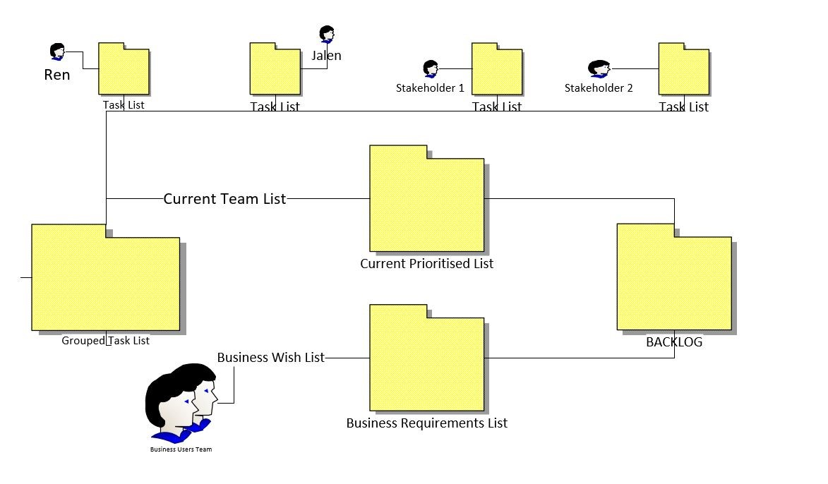

## References

Synopsys 21 Nov 2022 [What is DevOps](https://www.synopsys.com/glossary/what-is-devops.html#:~:text=Definition,than%20traditional%20software%20development%20processes)